Which demographic factors predict housing price in King County?

In plotting the median household income, average household income, unemployment rate, and income per capita against the average home sales price by zip code in King County and running a regression for each plot, we discover that each of these demographic factors can be predictors of housing price in King County.

The r-value for average home sales price vs. median household income is 0.67 which implies a fairly tight, positive correlation and implies that as the median household income goes up the average home sales price is expected to go up as well.

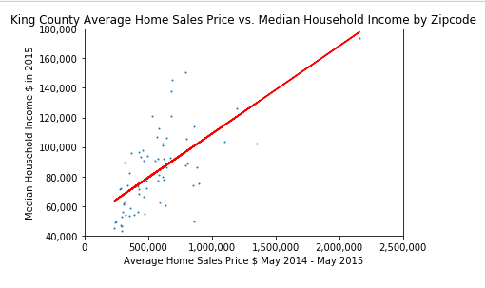

The r-value for average home sales price vs. average household income is 0.83 which implies a very tight, positive correlation and implies that as the average household income goes up the average home sales price is expected to go up as well.

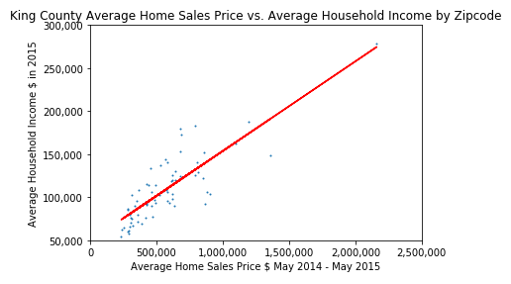

The r-value for average home sales price vs. unemployment rate is -0.5 which implies a fair, negative correlation and implies that as the unemployment rate in an area goes up the average home sales price is expected to go down.

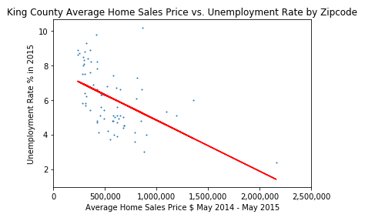

The r-value for average home sales price vs. income per capita is 0.9 which implies a very strong, positive correlation and implies that as the income per capita goes up the average home sales price is expected to go up.

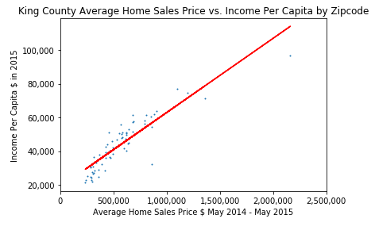

Is ethnicity related to housing price in King County?

In plotting bar charts of the various ethnicity distributions in King County for the zip codes with the five highest average home sales prices we see that in those zip codes, the percentage for the white ethnicity group is consistently higher than the percentage that group has overall in King County and the percentage for the hispanic and black ethnicity groups are consistently lower than the percentage those groups have overall in King County.

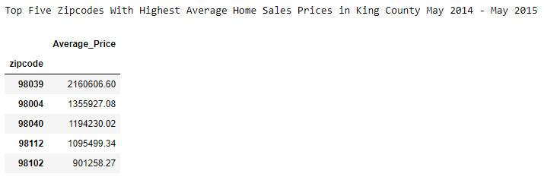

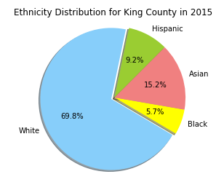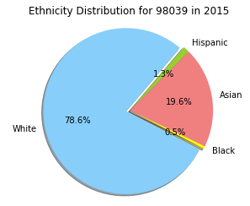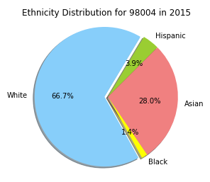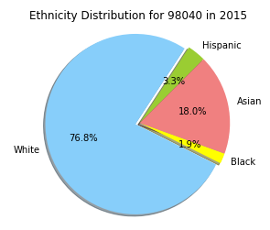

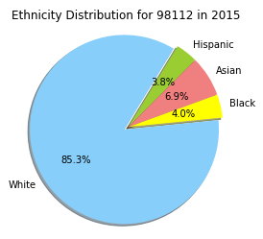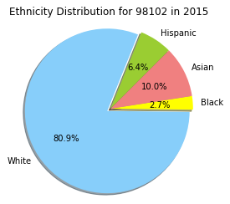

In plotting bar charts of the various ethnicity distributions in King County for the zip codes with the five lowest average home sales prices we see that in those zip codes, the percentage for the hispanic ethnicity group is consistently higher than the percentage that group has overall in King County and the percentage for the white ethnicity group is consistently lower than the percentage that group has overall in King County.

